Shayan Asghar
22i-2675
Lab 7
https://github.com/MuhammadShayanAsghar/22i2675_WebLabTasks2026/tree/main/Web_LabTasks

Task 6
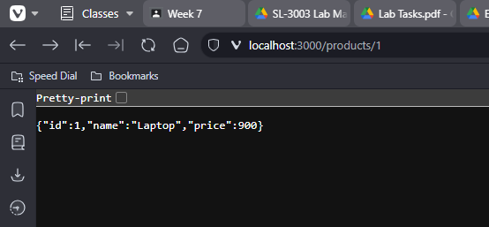
Task 7
